**Ideation Phase**

**Define the Problem Statements**

|  |  |
| --- | --- |
| Date | 19 September 2022 |
| Team ID | PNT2022TMID27357 |
| Project Name | Project - AI-powered Nutrition Analyzer for Fitness Enthusiasts |
| Maximum Marks | 2 Marks |

**Customer Problem Statement :**

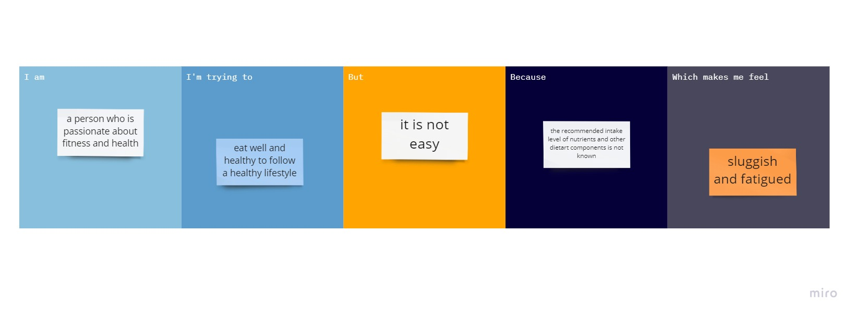

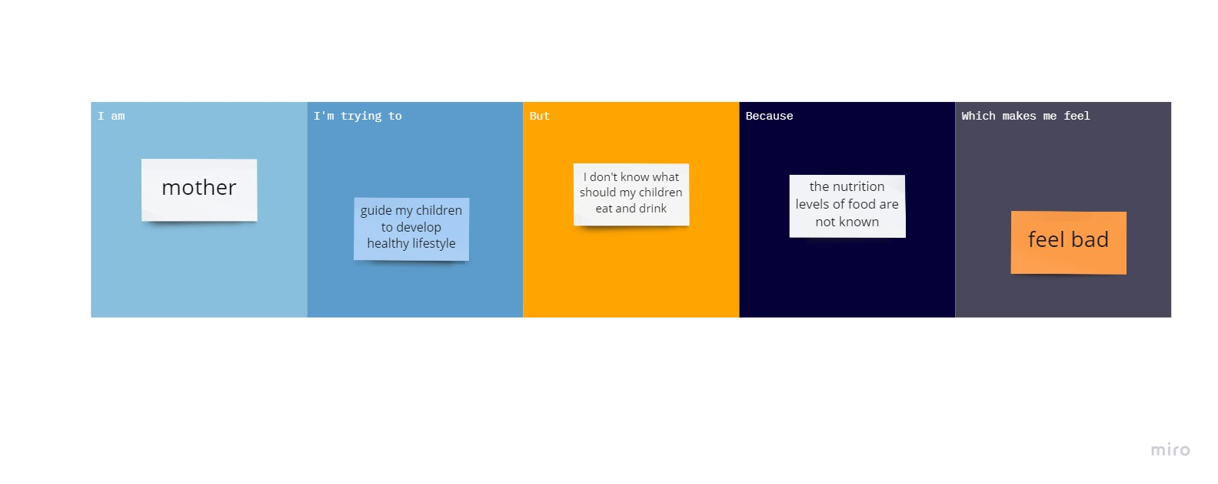

|  |  |  |  |  |  |
| --- | --- | --- | --- | --- | --- |
| **Problem Statement (PS)** | **I am (Customer)** | **I’m trying to** | **But** | **Because** | **Which makes me feel** |
| PS-1 | a person who is passionate about fitness and health | eat well and healthy to follow a healthy lifestyle | It is not easy | the recommended intake level of nutrients and other dietary components is not known | Sluggish and fatigued |
| PS-2 | a mother | Guide my children to develop healthy lifestyle | I don’t know what should my children eat and drink | The nutrition levels of food are not known | Feel bad |